Table of Contents Page-No
Class Diagram…………………………..…….…………………..………...2
Domain Model…………………………..…….…………………..………...4
ERD Diagram…………………………..…….…………………..………....6
Component Diagram…………………………..…….…………………...8
Deployment diagram…………………………..…….………………..…..8
Sequence Diagram…………………………..…….……………….……….9
Activity Diagram…………………………..…….…………………..……..22
Architecture Diagram…………………………..…….……………….….31

Class Diagram

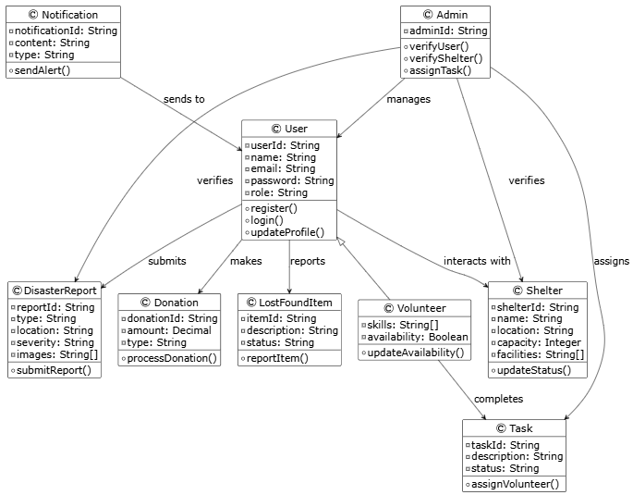
RelationShips
- Admin manages Users:
Admins can manage user accounts, such as verifying or disabling them.
- Admin verifies Shelters:
Admins are responsible for checking and approving shelters for use.
- User submits Disaster Reports:
Users can report disasters by submitting relevant information.
- Admin verifies Disaster Reports:
Admins check and validate the disaster reports submitted by users.
- Admin assigns Tasks:
Admins create and assign tasks that need to be completed during disaster response.
- Volunteer completes Tasks:
Volunteers are assigned tasks and are responsible for completing them.
- User interacts with Shelters:
Users can view, access, or seek refuge in available shelters.
- Notification sends alerts to Users:
The system sends notifications or alerts to users, such as warnings or updates.
- User makes Donations:
Users can donate money or resources to help during disasters.
- User reports Lost and Found Items:
Users can report items they lost or found during a disaster.
- Volunteer is a type of User:
A Volunteer is a specialized type of User with additional attributes like skills and availability.

Domain Model
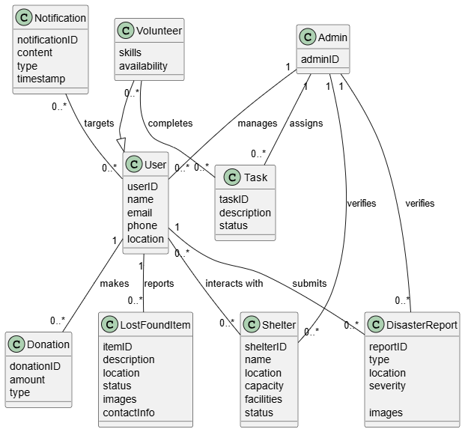
Relationships
- Admin manages Users:
An Admin can oversee many Users (like checking or disabling their accounts), but each User is managed by only one Admin.
- Admin verifies Shelters:
An Admin checks and approves many Shelters to make sure they are safe and legitimate, but each Shelter is verified by one Admin.
- Admin verifies Disaster Reports:
An Admin reviews many Disaster Reports to ensure they are accurate, but each Disaster Report is verified by one Admin.
- Admin assigns Tasks:
An Admin can give many Tasks to Volunteers, but each Task is assigned by one Admin.
- User submits Disaster Reports:
A User can send multiple Disaster Reports about incidents like floods or earthquakes, but each Disaster Report comes from one User.
- Volunteer completes Tasks:
A Volunteer can work on many Tasks, and a Task can be done by many Volunteers (for example, a team effort).
- User interacts with Shelters:
A User can visit or seek help from many Shelters, and a Shelter can help many Users.
- Notification targets Users:
A Notification (like an emergency alert) can be sent to many Users, and a User can receive many Notifications.
- User makes Donations:
A User can make multiple Donations (like money or supplies), but each Donation is made by one User.
- User reports Lost or Found Items:
A User can report many Lost or Found Items, but each Lost or Found Item is reported by one User.
- Volunteer is a type of User:
A Volunteer is a special kind of User who has extra details like skills and availability for helping in disasters.

ERD Diagram
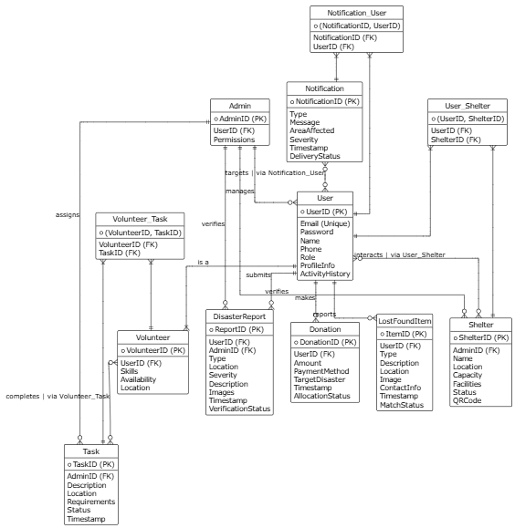

Relationships
- Admin manages Users
One Admin can manage many Users (like verifying or disabling accounts).
Each User is managed by one Admin.
- Admin verifies Shelters
One Admin can verify multiple Shelters.
Each Shelter is verified by a single Admin.
- Admin verifies Disaster Reports
Admins review and verify reports submitted by Users.
One Admin can verify many Reports, but each Report is verified by one Admin.
- Admin assigns Tasks
An Admin can assign many Tasks to Volunteers.
Each Task is assigned by one Admin.
- User submits Disaster Reports
A User can submit many Disaster Reports.
Each Report belongs to one User.
- Volunteer completes Tasks
A Volunteer can work on many Tasks.
A Task can also have many Volunteers (many-to-many).
- User interacts with Shelters
A User can interact with many Shelters (e.g., stay or visit).
A Shelter can serve many Users (many-to-many).
- Notification targets Users
A Notification can be sent to many Users.
A User can receive many Notifications (many-to-many).
- User makes Donations
A User can make many Donations.
Each Donation is made by one User.
- User reports Lost or Found Items
A User can report many Lost/Found Items.
Each Item is reported by one User.
- Volunteer is a type of User
A Volunteer has all the basic properties of a User, plus extra attributes (like skills and availability).
This is a specialization or inheritance relationship

Component Diagram
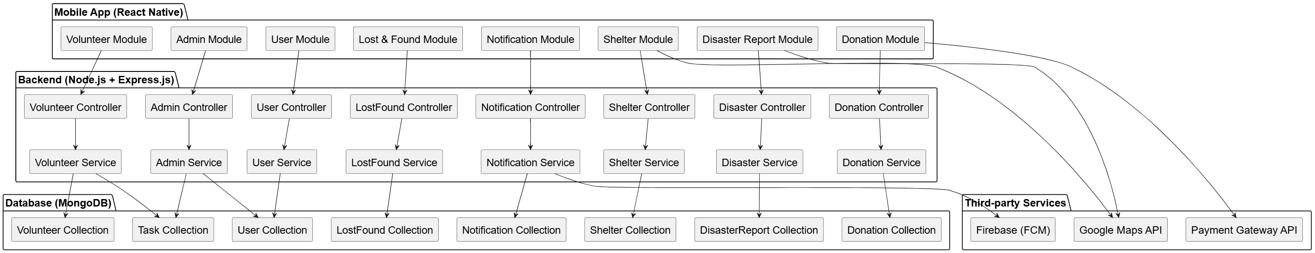
Deployment diagram
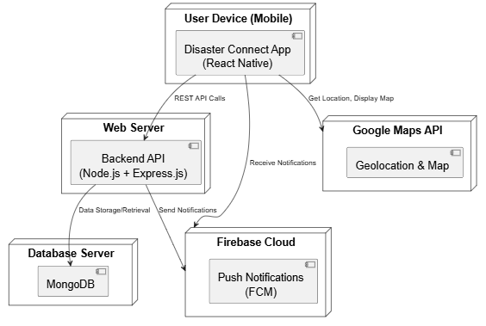

Sequence Diagrams
User Management
User Registration:
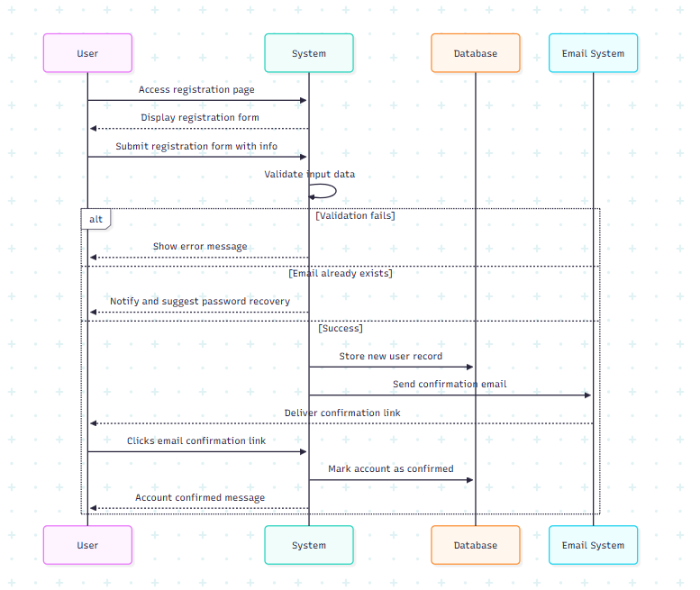

User Login:
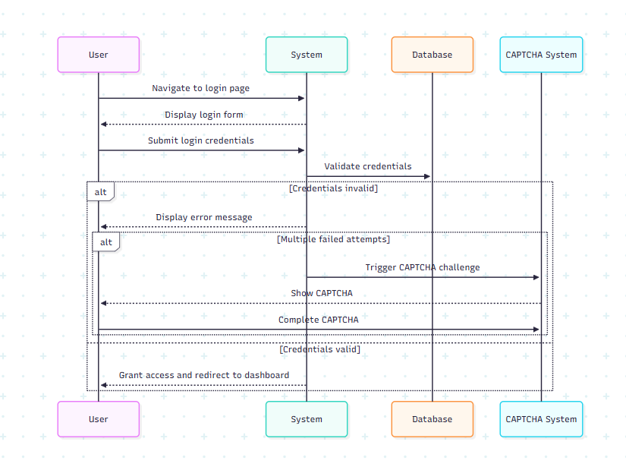

Disaster Reporting

Report Disaster Incident:
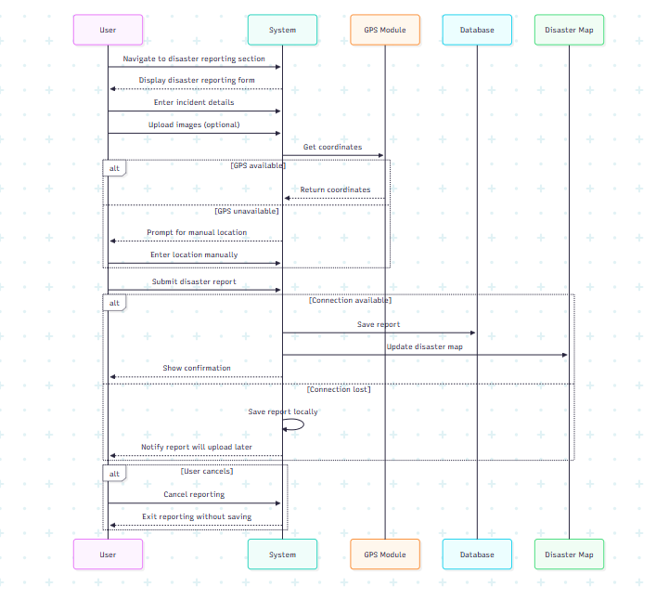

View Disaster Map:
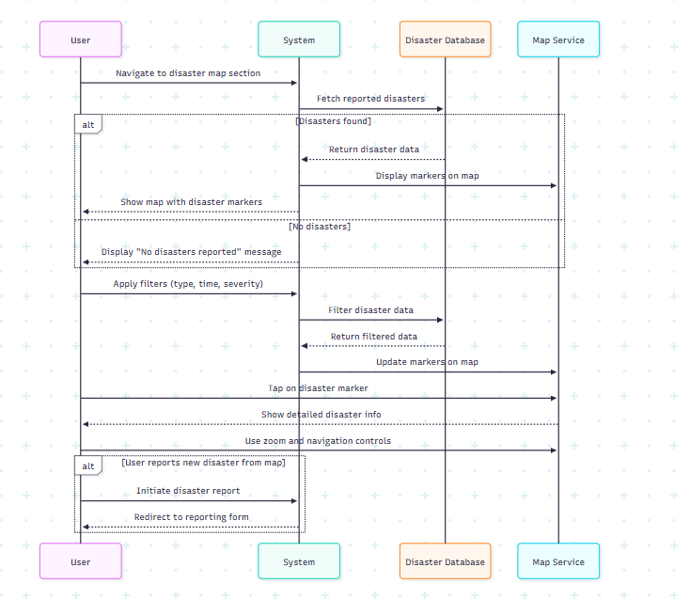

Volunteer Management
Register as Volunteer:
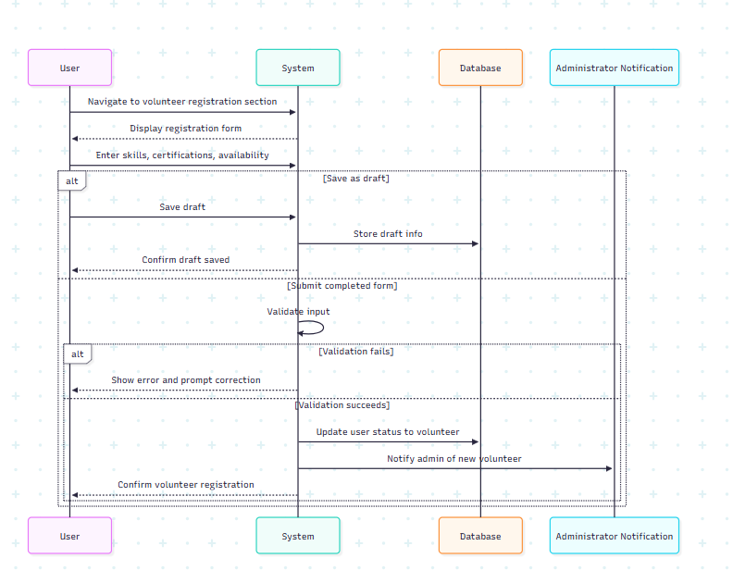

Assign Volunteer Task:
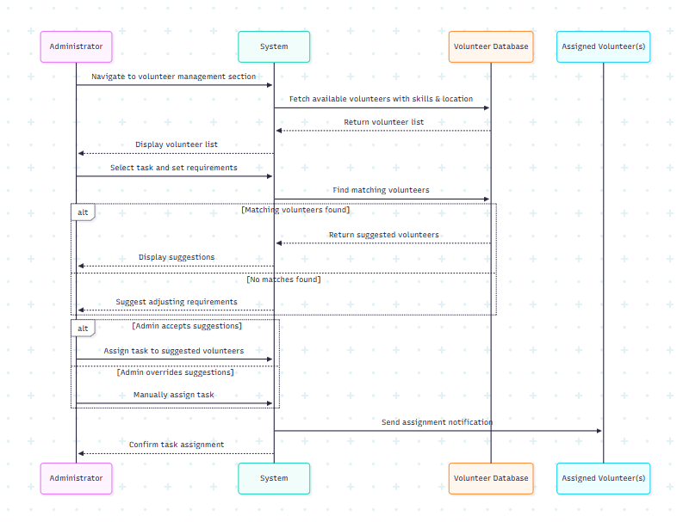

Shelter Management
Register New Shelter:
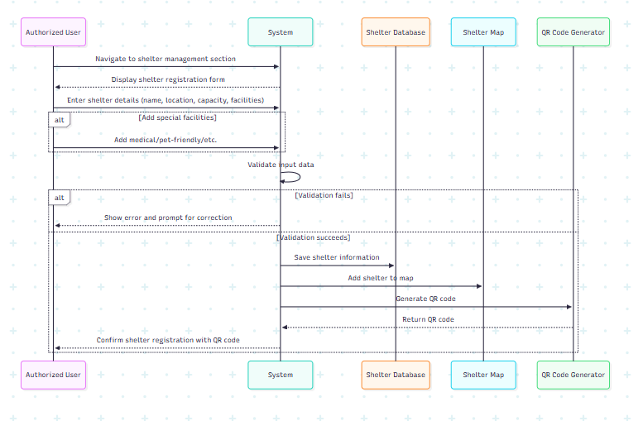

Find Nearest Shelter:
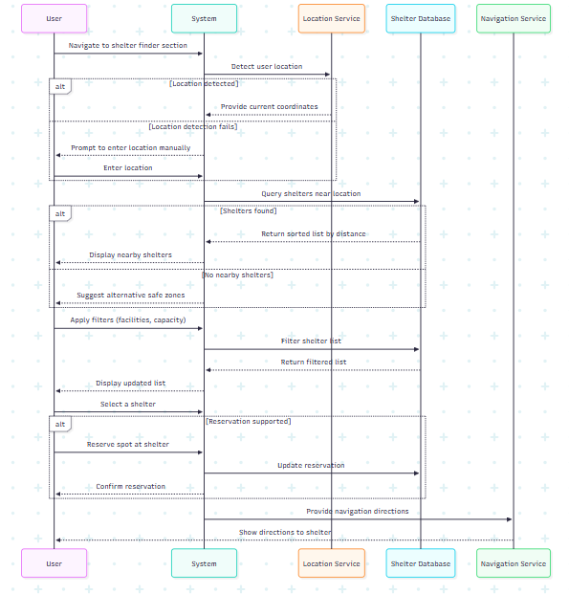

Notification System
Send Emergency Alert:
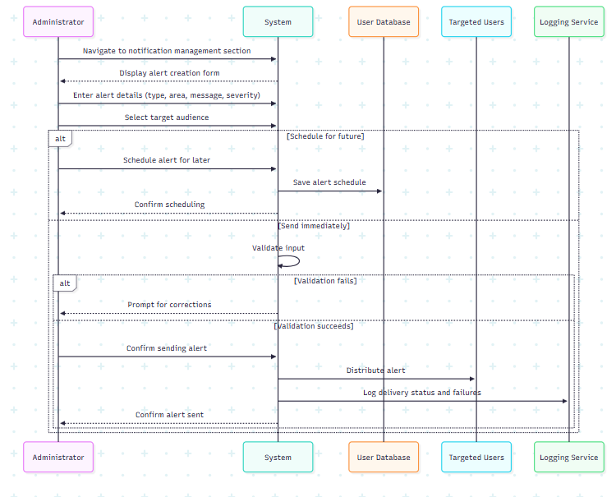

Donations
Make Monetary Donation:
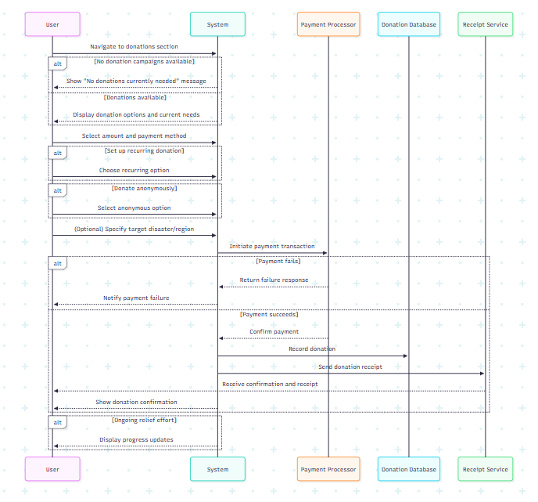

Lost and Found
Report Lost Item:
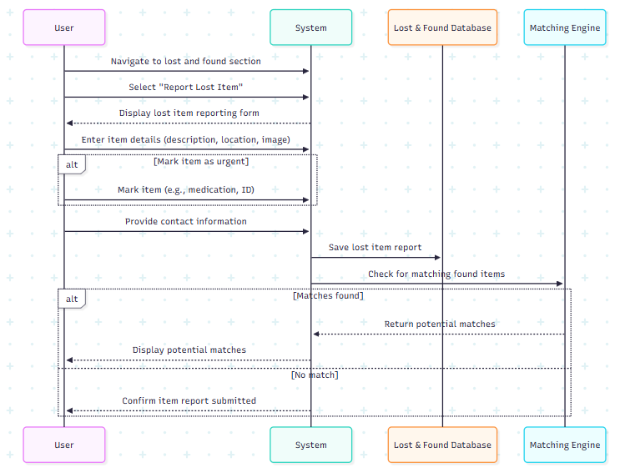

Report Found Item:
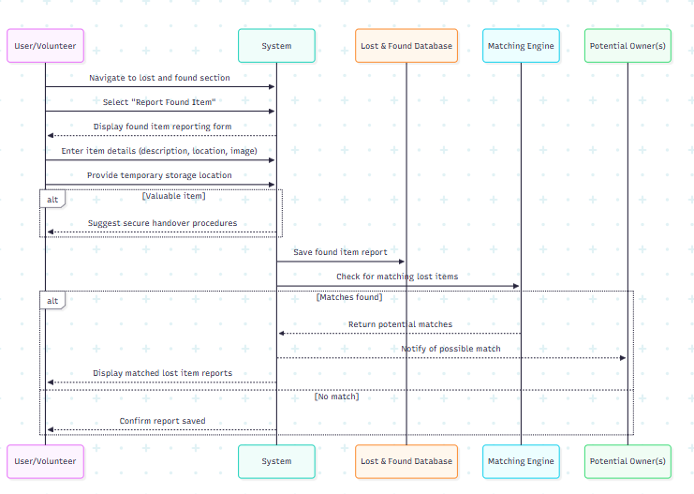

Match Lost & Found:
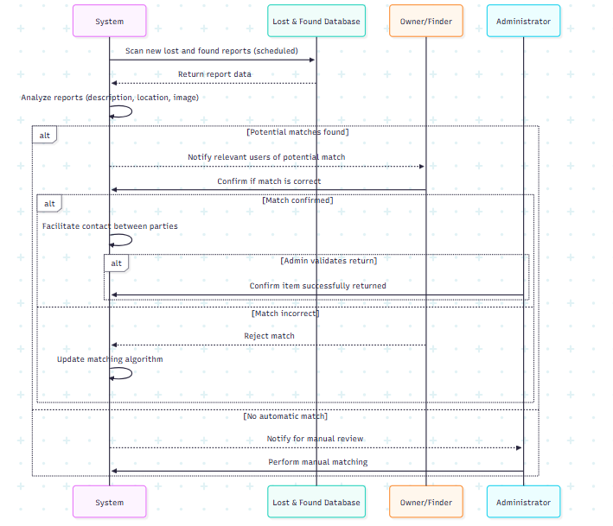

Activity Diagram
User Management
User Registration:
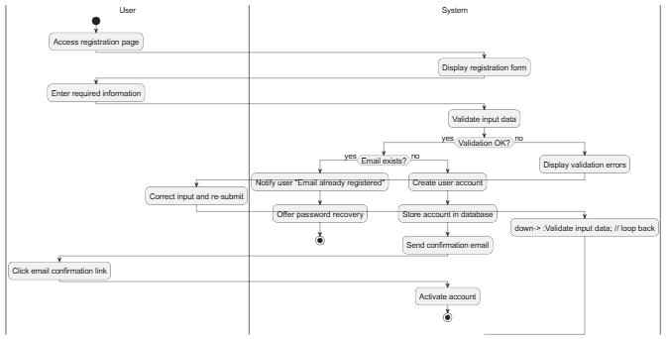
User Login:
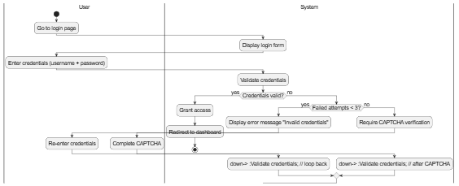

Disaster Reporting
Report Disaster Incident:

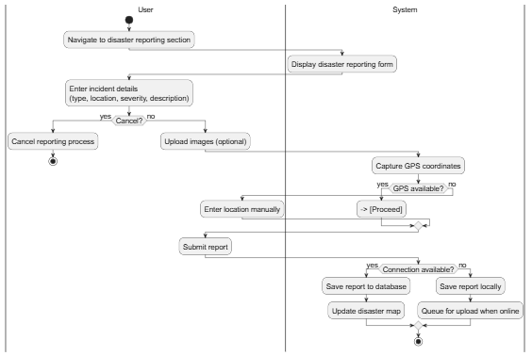

Volunteer Management
Register as Volunteer:
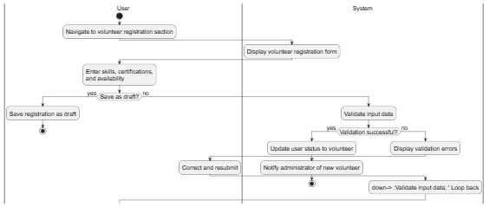
Assign Volunteer Task:
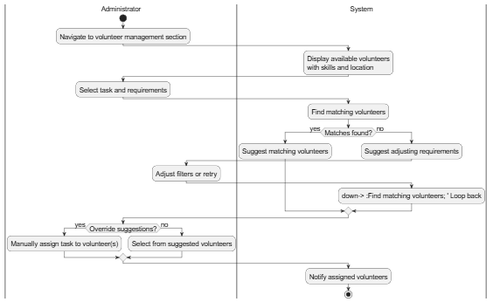

Shelter Management
Register New Shelter:
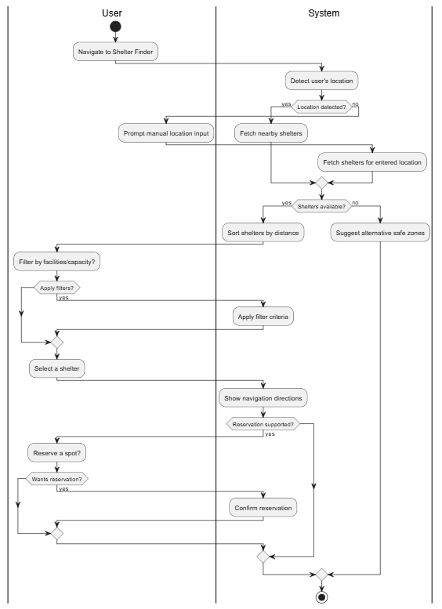
Find Nearest Shelter:
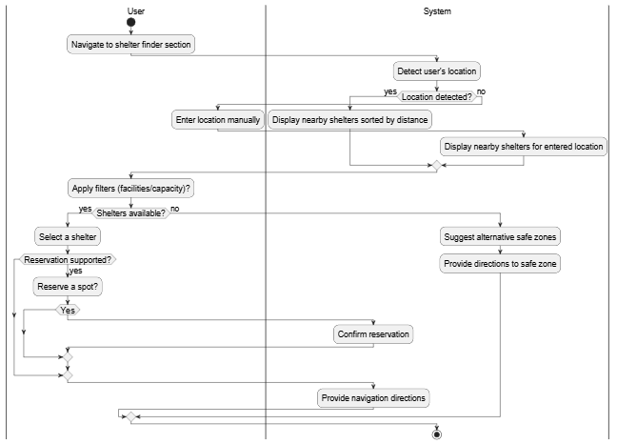

Notification System
Send Emergency Alert:
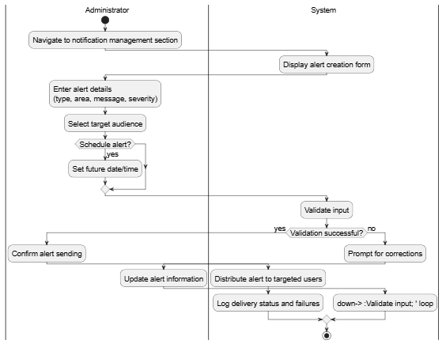

Donations
Make Monetary Donation:
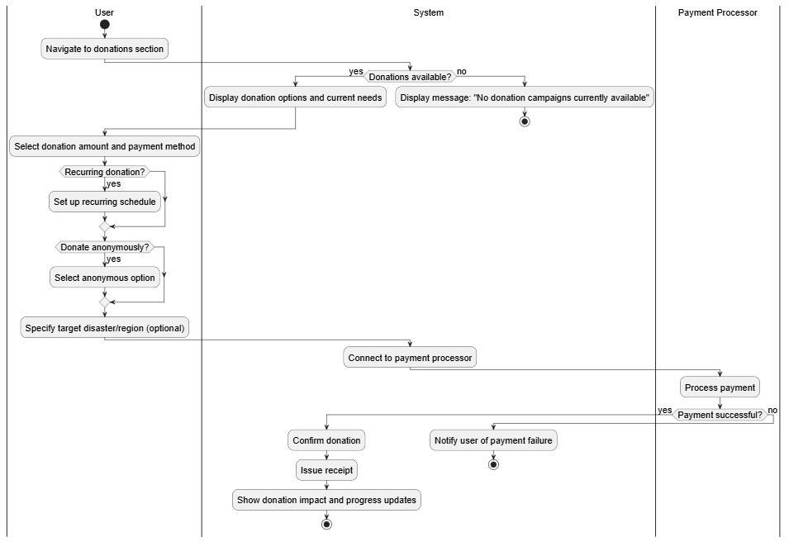

Lost and Found
Report Lost Item:
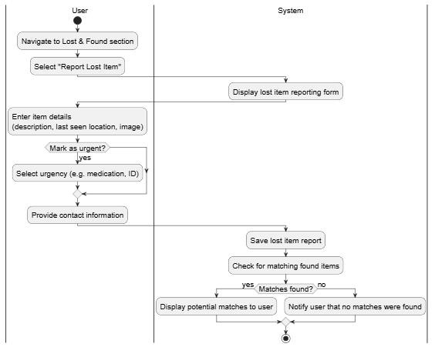

Report Found Item:
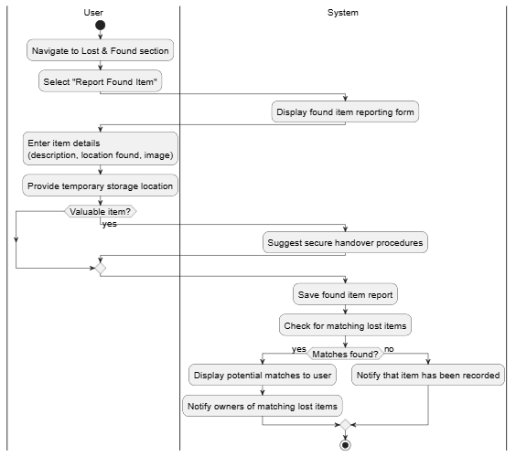
Match Lost & Found:
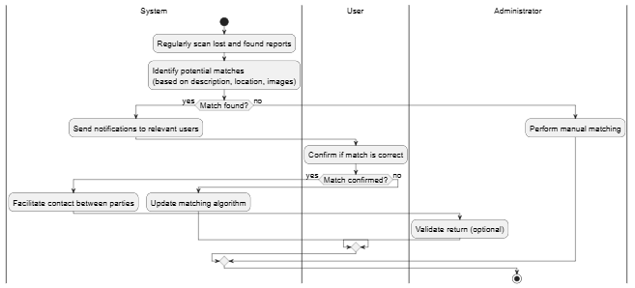
Architecture Diagram
